VVDIprog

1. The built-in update software allows user to update VVDI Prog firmware timely.
2. High-speed USB communication interface enable the software automatically connect.
3. Smart operation mode: the possible causes of error will be listed
4. Reserve ports: for future update.
5. The self-test function enable you check if the machine works well.
6. Can supply power via USB cable, the software will automatically prompt if the external USB power supply is needed.

**VVDI PROG Programmer**  
  
1. Support R&W lots of chips, include MC9S08 series, MC68HC(9)12 series,MC9S12 series, V850 series, H8X series, R8C series, PCF79XX series and most eeprom chips  
2. Support chip data verify, check blank function  
3. Support data file compare function  
4. Support R&W BMW N20, N55 ECU ( show ISN directly )  
5. Stable R&W MC9S12XE series chips (5M48H/1N35H/2M53J/3M25J etc.)  
6. Support renew PCF79XX remote, currently support BMW E/F series  
7. Lots of connection diagram

**VVDI Prog Programmer Unit Description:**

1.16 Pin DIP socket Function:  
Read EEPROM chips Use method: Follow the image direction when insert the DIP chip (PIN1 as yellow point show as the picture);  
SOP chip need soldering on 16Pin adaptor first, then insert the chip follow the image direction

**How To Update VVDI Prog Programmer Online**

This function require internet support  
Click the “Upgrade” button enter the upgrade interface, show as following picture  
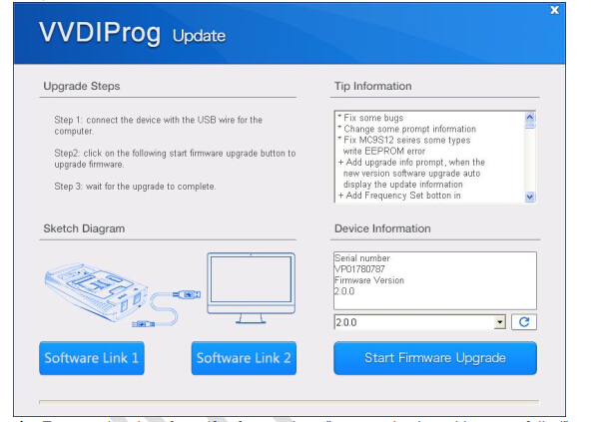  
Enter update interface, if software show ”communication with server failed”,please close your Anti-virus and computer firewall and retry. If software show “unable to find equipment”, please reconnect device  
Tip information show the latest software version and upgrade information  
 Device information show the device SN, device firmware version and the latest firmware version  
  
**Firmware upgrade steps:**  
1. Select the firmware version  
2. Click “Start Firmware Upgrade” button  
3. Don’t close or pull out USB cable before upgrade finished  
  
**Software upgrade steps:**  
1. Click “Software Link 1” or “Software Link 2” button, download software from the web  
2. Extract the file

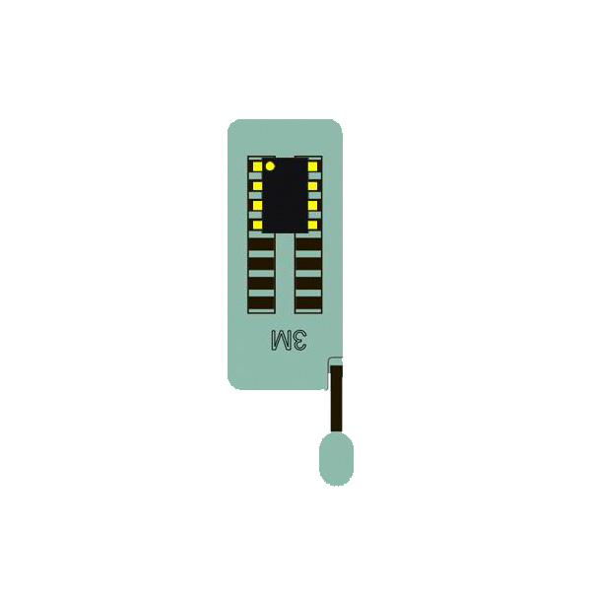  
**2. MCU Reflash Cable**  
**Function:**       Read & Write MC68HC(9)12, V850, H8X, R5C series chips,current version is V2  
**Use method:**Soldering the line on pin of chip before read & write  
 **Notes:**  
     (1) Please check all connection lines,ensure correct and reliable connection  
     (2) Please Don’t lengthen CLK and GND-C line, maybe cause read data failed.  
  
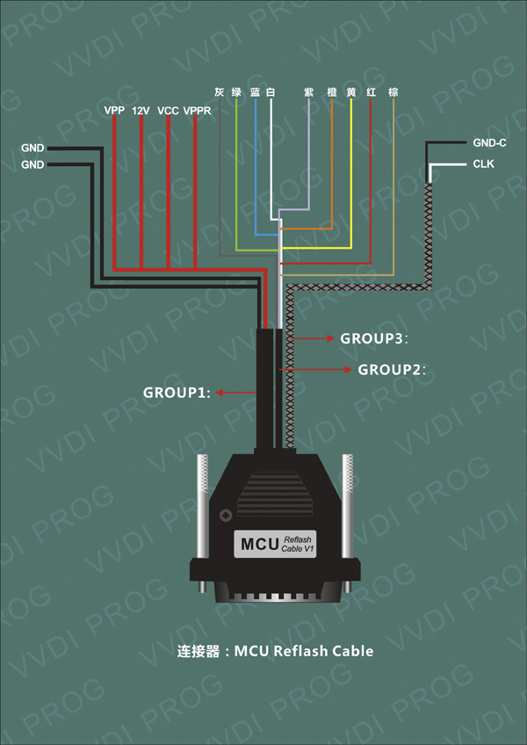  
**3. ECU Reflash Cable**  
**Function:**Read & Write engine ECU  
**Use method:**   Connect the ECU and R&W  
**Notes:**               Please check all connection lines, ensure correct and reliable connection  
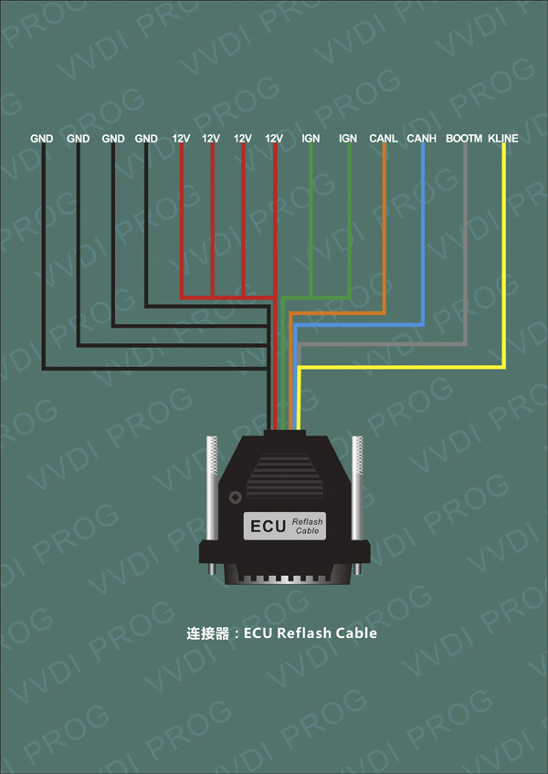  
  
**4.MC9S12 Reflash Cable**  
**Function:** Read & Write MC9S08, MC9S12 series chips, current version is V1  
**Use method:**Soldering the line on pin of chip before read & write  
**Notes:**  
       (1) Please check all connection lines,ensure correct and reliable connection.  
       (2) Please Don’t lengthen CLK and GND-C line, maybe cause read data failed.  
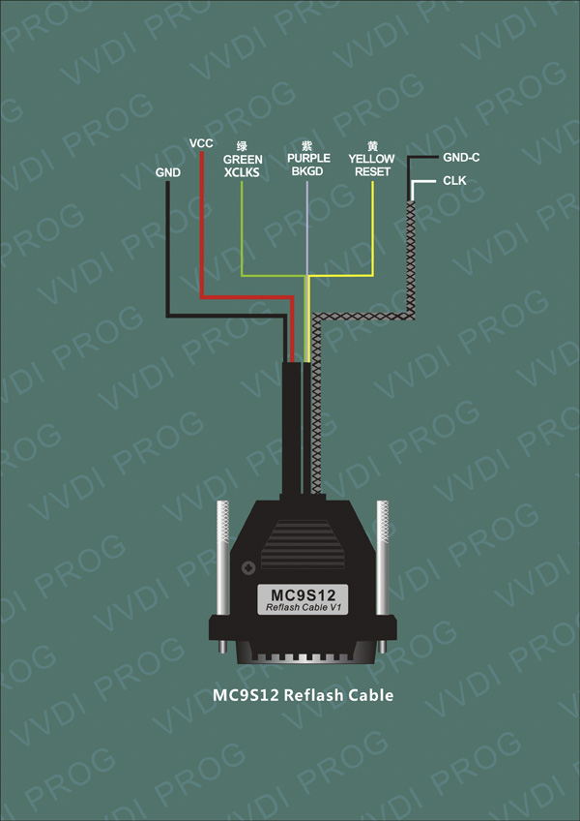

**VVDI Prog Programmer Package List:**

1. VVDI Prog device  
2. EEPROM Socket  
3. EEPROM Adapter  
4. MC9S12 Reflash Cable V1  
5. MCU Reflash Cable  
6. ECU Reflash Cable  
7. USB B-Tyte Cable